Contact Manager
Ideation Phase
Brainstorm & Idea Prioritization

Date | 07/03/2026
Team ID | 69a7b691e8fb1cec77265107
Project Name | Contact Manager
Maximum Marks | 4 Marks

Brainstorm & Idea Prioritization
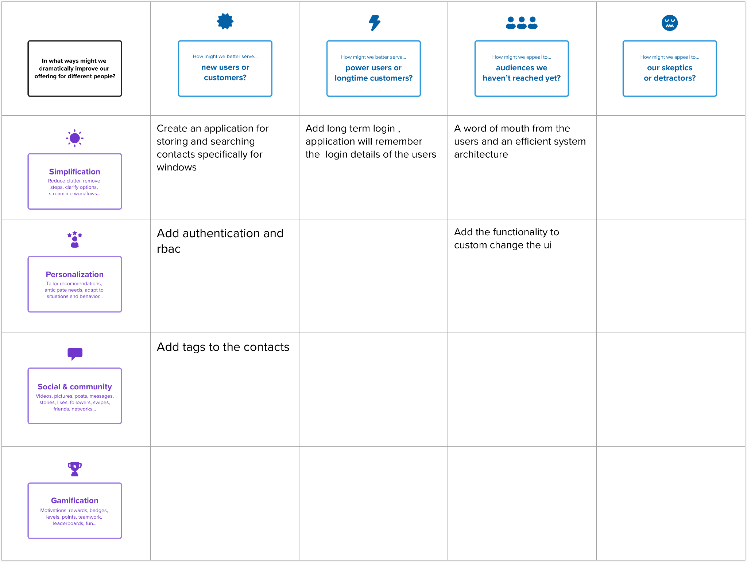

Ste 2 : Idea Prioritization
